No. | Item
1 | Hydraulic Press  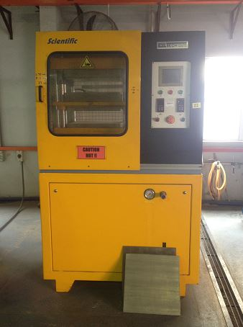
2 | Drying Oven  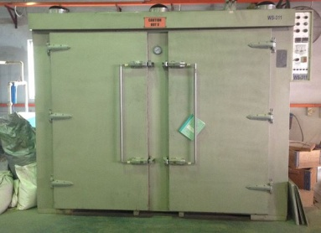
3 | Particle Adhesive Blender  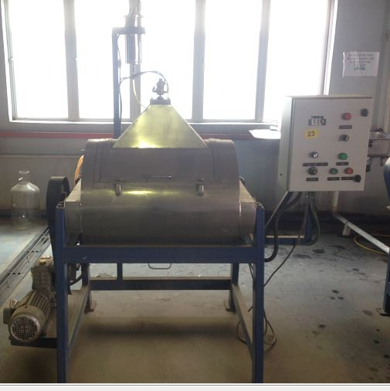
4 | Fiber Glue Mixer  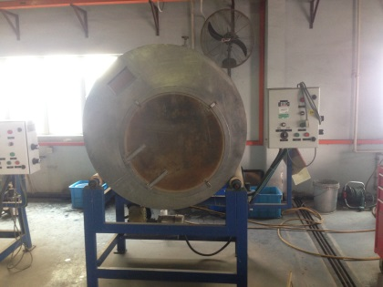
5 | Water Heater Tank (3 Unit)  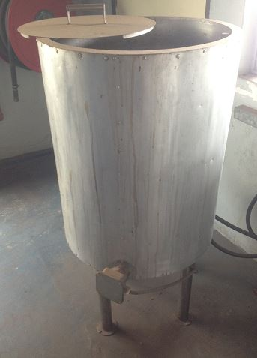
6 | Rotary Screw Air Compressor including Air Tank Pressure  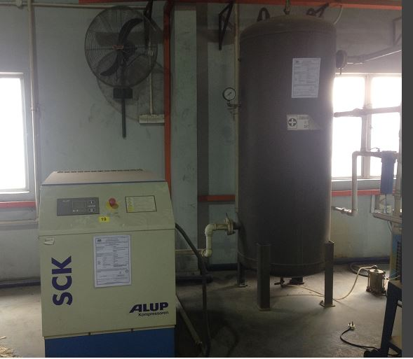
7 | Crusher  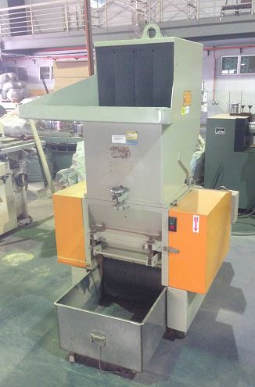
8 | Combination Wood Compressor  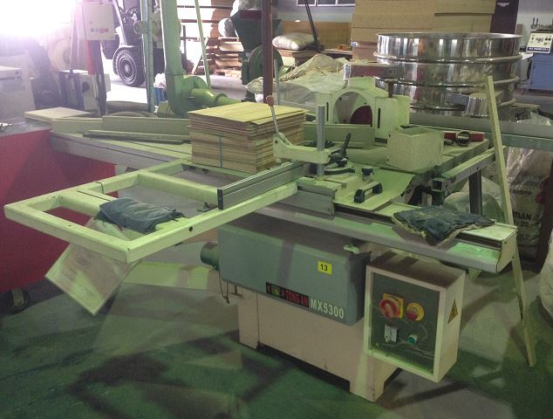
9 | Altendorf F45 ( Band Saw )  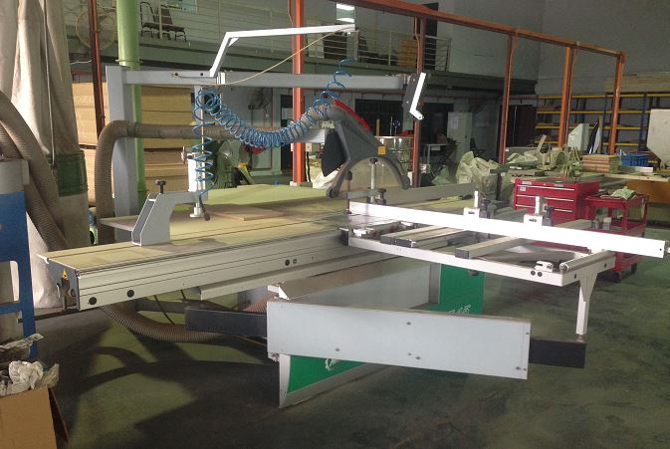
10 | Radial Arm Saw  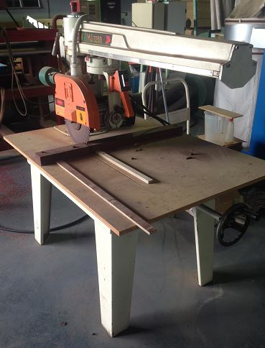
11 | Band Saw With Power Feeder  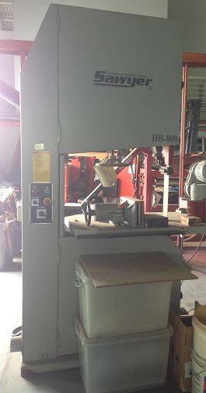
12 | Small Band Saw  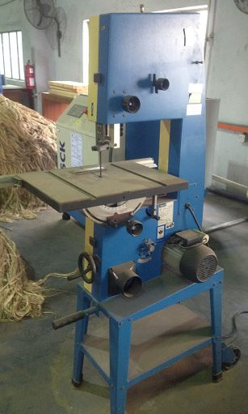
13 | Co-rotating Twin Screw Extruder  Extruder  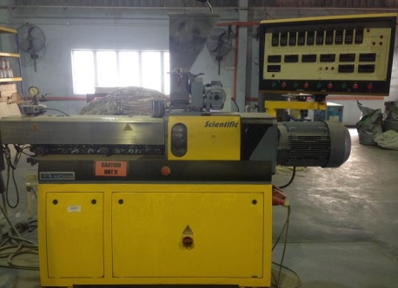  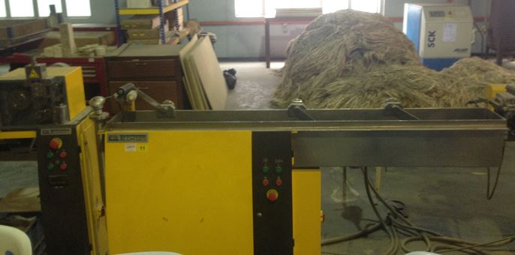
14 | Vibrating Screening Machine  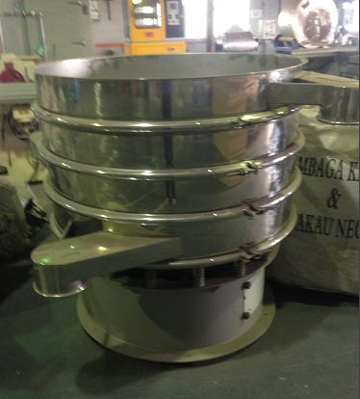
15 | Moulding test process  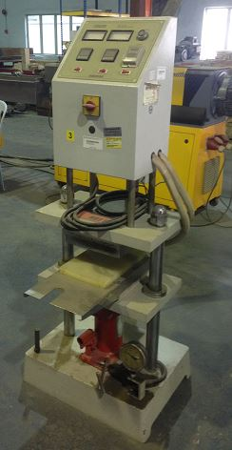
16 | Two Roll Mixing Mill  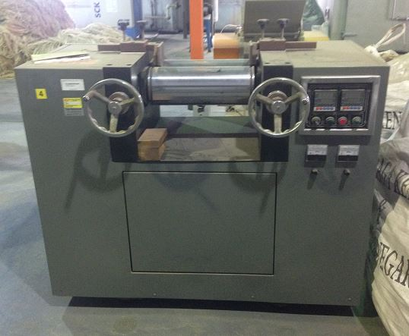
17 | Dispersion kneader Mixer  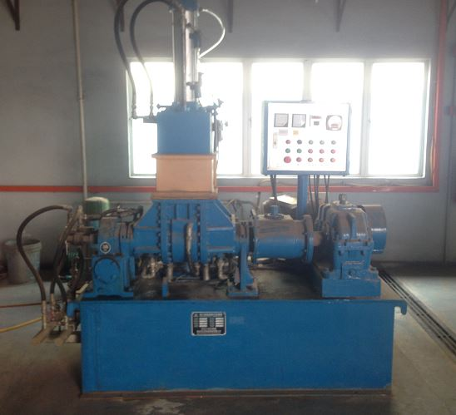
18 | Mobile saw (BEAR CAT)  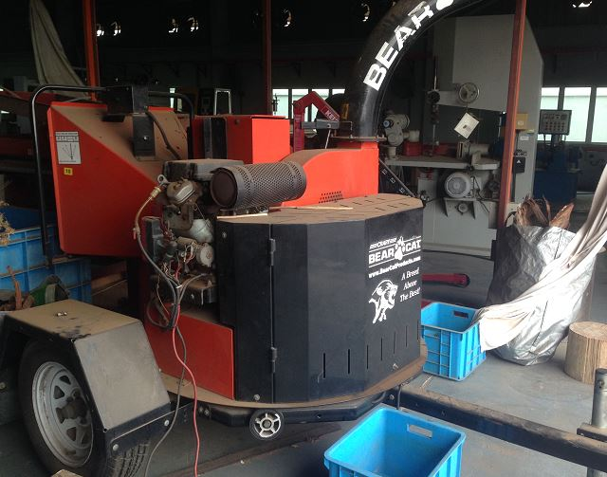
19 | Infra Red Pre-heat Oven  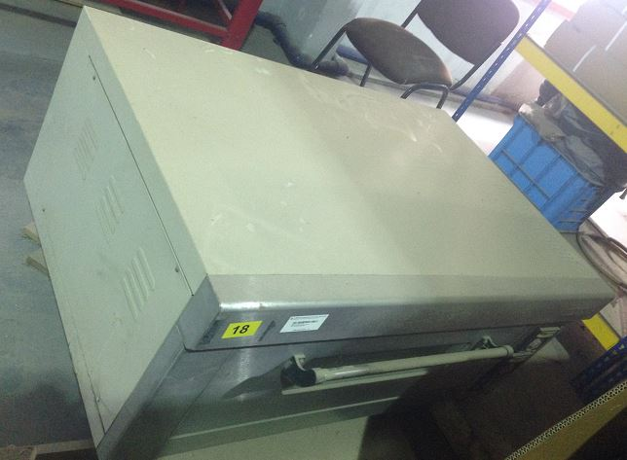
20 | Universal Oven  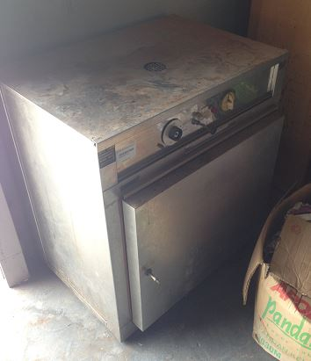
21 | Kenedy hydraulic lifter  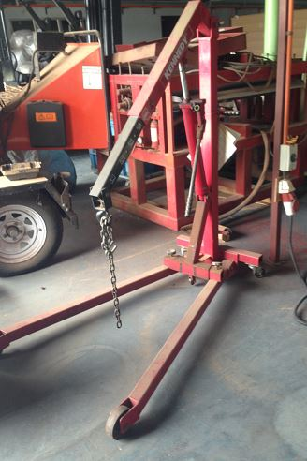
22 | Thermoforming machine  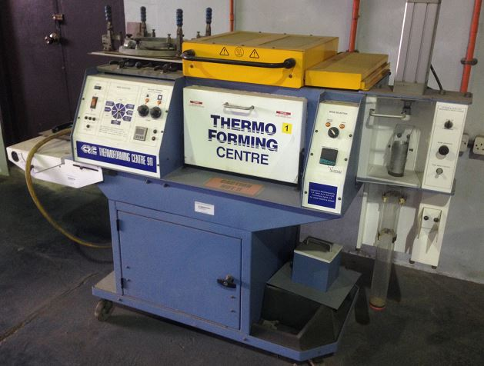
23 | Unit Test machine  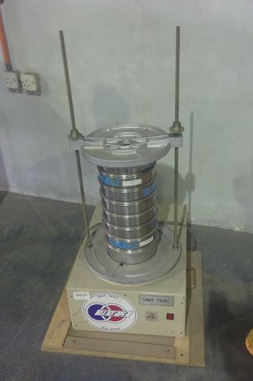
24 | Rotary saw machine  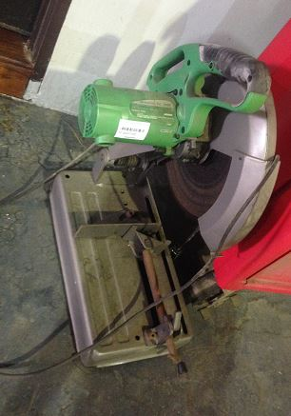
25 | Drilling machine  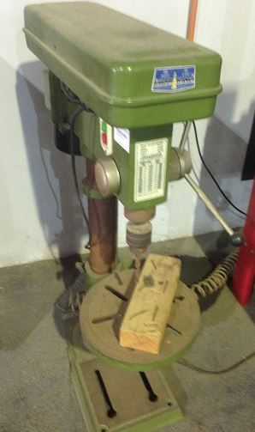
26 | Mesh Drum (4 unit)  